Name ________________________
PHY2018C, Quiz 2

A- Read all the quiz once, or twice, before beginning to write. Make sure to comprehend all questions and start with those you feel most confident.
B – Be clear and concise. There are no extra points for being verbose or writing extra.
C –Only use the white pages that I will provide. You have 50 minutes to answer the quiz.
---------------------------------------------------------------------------------------------------------------------------

Problem 1

The proportion between male and female voters is 5:3 when there are no female presidents running and 1:1 when there is a female president running. A million more females vote when a female president is running. What’s the ratio between the number of male voters in both elections?
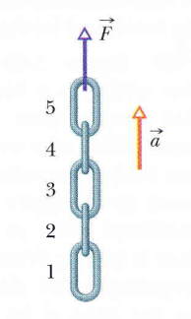

Problem 2 (From Halliday, Resnik, Walker)

When we say things like: “Air Force pilots have to sustain an acceleration of 5g during combat” we mean the total acceleration plus the gravitational acceleration. To know how many g’s a body is sustaining one must treat the acceleration as a fictitious force and combine the effects of this acceleration with gravity (for instance, even if you are not accelerating now, you are withstanding 1 g due to gravity). In the Figure, a chain consisting of five links, each of mass 0.327 kg, is lifted vertically with constant acceleration of magnitude a = 9.81 m/s2. Each link pair can only sustain a gravitational acceleration of 5g before they break where their join. (a) How many g’s is the chain withstading? (b) What’s the minimum acceleration a you can pull the chain without braking it?

Problem 3 (OpenStax)

A ball rests on a table hanged on a string which is almost (bot not quite) suspending it over the table. (a) Draw a free-body diagram for the table. (b) Draw a free-body diagram for the book.

