Name ________________________
PHY2048C, Quiz 6

A- Read all the quiz once, or twice, before beginning to write. Make sure to comprehend all questions and start with those you feel most confident in.
B – Be clear and concise. There are no extra points for being verbose or writing extra.
C –Only use the white pages that I will provide. You have 50 minutes to answer the quiz.
---------------------------------------------------------------------------------------------------------------------------

Problem 1

A 1.50 m string of weight 0.0125 N is tied to the ceiling at its upper end, and the lower end supports a weight W. Ignore the very small variation in tension along the length of the string that is produced by the weight of the string. When you pluck the string slightly, the waves traveling up the string obey the equation

where A = 8.0 mm, a = 162 rad/m and b = 4830 rad/s.

Assume that the tension of the string is constant and equal to W. (a) How much time does it take a pulse to travel the full length of the string? (b) What is the weight W? (c) How many wavelengths are on the string at any instant of time? (d) What is the equation for waves traveling down the string?

Problem 2

What distinguishes a wave from an oscillation? Be concise.

Problem 3

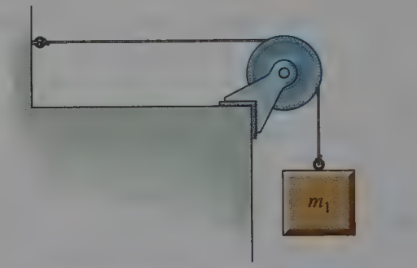
A mass m, is attached to a wire of linear density 5.6 g/m, and the other end of the wire run over a pulley and tied to a wall as shown in Figure 1. The speed of transverse waves on the horizontal section of wire is observed to be 20 m/s. If a second mass m, is added to the first, the wave speed increases to 45 m/s. Find the second mass. Assume the string does not stretch appreciably.

Figure 1
Problem 4
Show that the quantity has the units of speed.

