Name ________________________
PHY2048C, Quiz 5

A- Read all the quiz once, or twice, before beginning to write. Make sure to comprehend all questions and start with those you feel most confident in.
B – Be clear and concise. There are no extra points for being verbose or writing extra.
C –Only use the white pages that I will provide. You have 50 minutes to answer the quiz.
---------------------------------------------------------------------------------------------------------------------------
Problem 1
A uniform beam of length L and mass m shown in the figure is inclined at an angle θ to the horizontal. Its upper end is connected to a wall by a rope, and its lower end rests on a rough, horizontal surface. The coefficient of static friction between the beam and surface is μS Assume the angle θ is such that the static friction force is at its maximum value. (a) Draw a force diagram for the beam. (b) Using the condition of rotational equilibrium, find an expression for the tension T in the rope in terms of m, g, and θ.
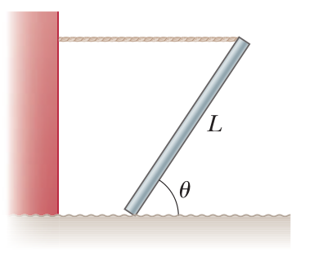

Problem 2
A 60-kg uniform board 2.4 m long is supported by a pivot 80 cm from the left end and by a scale at the right end (Fig. 12.14). How far from the left end should a 40-kg child sit for the scale to read zero?

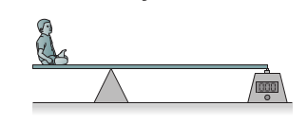

Problem 3
Ahmad, Sebas and Barbara were given some money each. After Ahmad spends B/.50 each day and Sebas spends B/. 25 each day, and Barbara spends B/. 10 each day during a fixed number of days, Ahmad still has B/.600 remaining while Sebas spent all his money and Barabara has the same amount that Sebas had at the beginning. If instead Ahmad spends B/. 25 and Sebas and Barbara B/. 75 each, each day during the same period, Ahmad will still have B/. 2100 while Sebas and Barbara owe money. How much money do Sebas and Barbara owe together?

