Name ________________________ PHY2049C, Quiz 10

A- Read all the quiz once, or twice, before beginning to write. Make sure to comprehend all questions and start with those you feel most confident in.
B – Be clear and concise. There are no extra points for being verbose or writing extra.
C –Only use the white pages that I will provide. You have 50 minutes to answer the quiz.
---------------------------------------------------------------------------------------------------------------------------
Problem 1
The current I in a long, straight wire is constant and is directed toward the right as in the figure. Conducting loops A, B, C, and D are moving, in the directions shown, near the wire. Rank in terms of maximum induced current in these loops, counterclockwise representing a positive current.
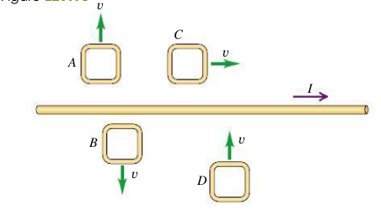

Problem 2
The figure below (left) shows three equal currents i (two parallel and one antiparallel) and four Amperian loops. Rank the loops according to the magnitude of ∫B ·ds along each, greatest first.
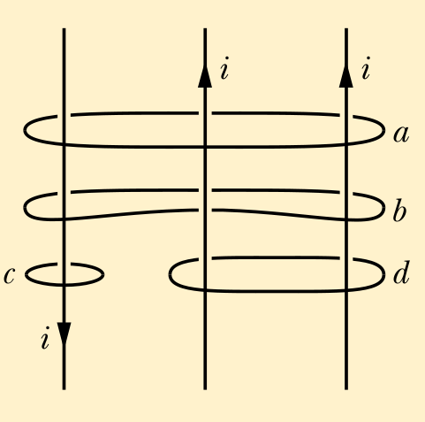

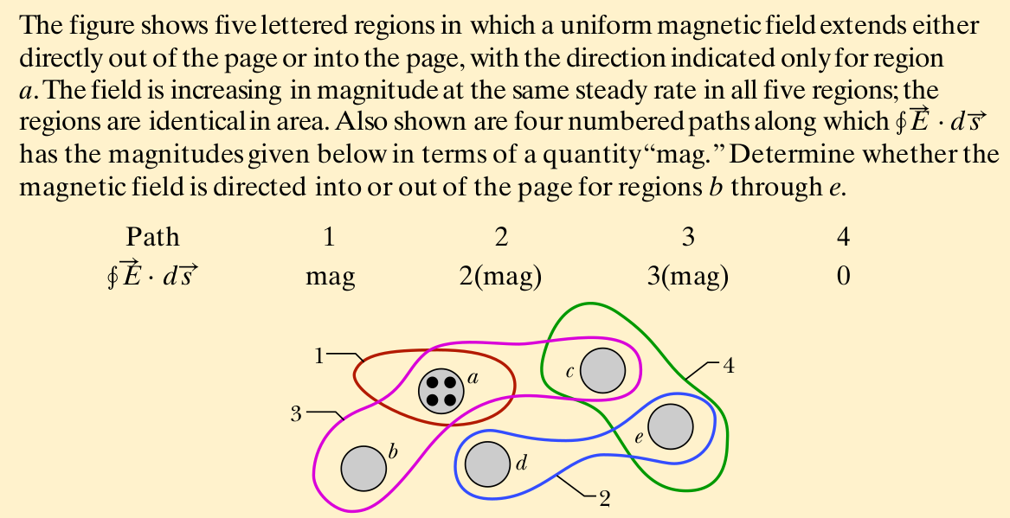

Problem 3
The figure above (right) shows five lettered regions in which a uniform magnetic field extends either
directly out of the page or into the page, with the direction indicated only for region
a. The field is increasing in magnitude at the same steady rate in all five regions; the
regions are identical in area. Also shown are four numbered paths along which ∮ E ⋅ d s
has the magnitudes given below in terms of a quantity “mag.” Determine whether the
magnetic field is directed into or out of the page for regions b through e.

