Name ________________________
PHY2049C, Quiz 10

A- Read all the quiz once, or twice, before beginning to write. Make sure to comprehend all questions and start with those you feel most confident in.
B – Be clear and concise. There are no extra points for being verbose or writing extra.
C –Only use the white pages that I will provide. You have 50 minutes to answer the quiz.
---------------------------------------------------------------------------------------------------------------------------
Problem 1
Find the net electric flux through (a) the closed spherical surface in a uniform electric field shown in Figure a and (b) the closed cylindrical surface shown in Figure b
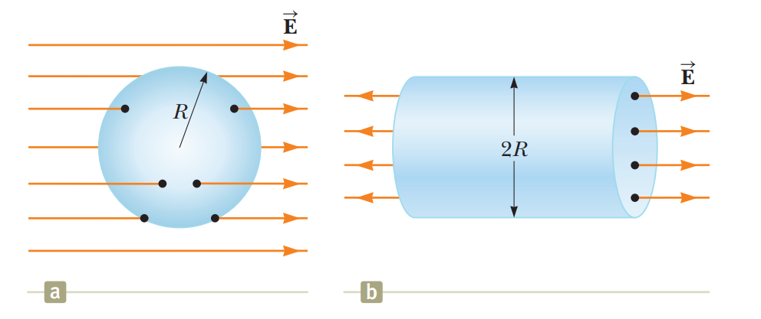
Problem 2
When a Coronal Mass Ejection occurs, the Sun ejects ions at 0.01c due to the reconnection of its magnetic field (c is the speed of light). The sun can eject approximately 10^20 kgs of mass in one ejection, all ions. Assume that the mass and charge of each ion are the mass and charge of the proton, 1.6726 x 10⁻²⁷ kilograms, 1.6*10^⁻¹⁹ C. Given that the Earth is at 1AU (1.49610^8 km) and has a radius of 6400 km and it includes the atmosphere, what is the maximum electric flux through Earth during a Coronal Mass ejection. c=2.99^10^8 m/s

Problem 3
You have an arrangement of Gaussian Surfaces and charges as follows:
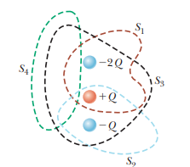
The cross is uncharged. Then, you add a charge of +3Q where the red cross is. What is the ratio between the old flux thought S1 over the new flux though S1.

