Name ________________________ PHY2049C, Quiz 10

A- Read all the quiz once, or twice, before beginning to write. Make sure to comprehend all questions and start with those you feel most confident in.
B – Be clear and concise. There are no extra points for being verbose or writing extra.
C –Only use the white pages that I will provide. You have 50 minutes to answer the quiz.
---------------------------------------------------------------------------------------------------------------------------
Problem 1
Below there are 3 collisions, I, II, and III. Their initial state in at the stop, the collision in the middle row, and the final state is at the bottom. Rank them in terms of their coefficient of restitution, greatest first.
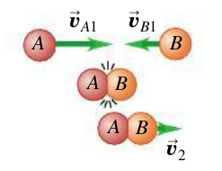
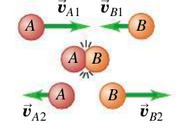
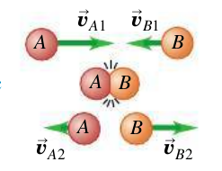

Problem 2
A 15.0-kg block is attached to a very light horizontal spring of force constant 500.0 N/m
and is resting on a frictionless horizontal table. Suddenly it is struck by a 3.00-kg stone traveling horizontally at 8.00 m/s to the right, whereupon the stone rebounds at 2.00 m/s horizontally to the left. Find the maximum distance that the block will compress the spring after the collision.
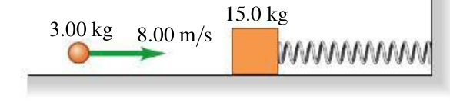

Problem 3

A team of two on a trivia game receives 100 points for each correct answer and loses 20 points for each incorrect answer. Yajaira and Leona answered a total of 55 questions together and scored a total of points 2500 points. Yajaira had 10 questions wrong, while the ratio of right and wrong for Leona was 2:1. How many questions did Leona get right?

