Name ________________________
PHY2049C, Quiz 8

A- Read all the quiz once, or twice, before beginning to write. Make sure to comprehend all questions and start with those you feel most confident in.
B – Be clear and concise. There are no extra points for being verbose or writing extra.
C –Only use the white pages that I will provide. You have 50 minutes to answer the quiz.
---------------------------------------------------------------------------------------------------------------------------
Problem 1
As seen in the Figure, a square loop of wire has sides of length 2.0 cm. A magnetic field is directed out of the page; its magnitude is given by B = 4.0t2y, where B is in teslas, t is in seconds, and y is in meters. At t = 2.5 s, what is the magnitude of the emf induced in the loop?

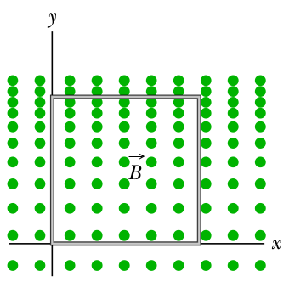

Problem 2

Inductors in parallel. Two inductors L1 and L2 are connected in parallel and separated by a large distance so that the magnetic field of one cannot affect the other. (a) Show that the equivalent inductance is given by
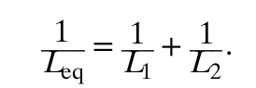
(Hint: Review the derivations for resistors in parallel and capacitors in parallel. Which is similar here?)

Problem 3
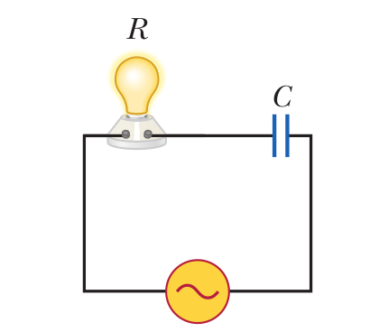
Consider the AC circuit in Figure 32.12. The frequency of the AC source is adjusted while its voltage amplitude is held constant. You pass through an AC signal for frequencies (a)f=f_{0,} (b)f=2f_{0 ,}(c)f=0.5f₀
Rank this situations in terms of which one makes the light bulb glow the brightest.

