Name ________________________ PHY2049C, Quiz 8

A- Read all the quiz once, or twice, before beginning to write. Make sure to comprehend all questions and start with those you feel most confident in.
B – Be clear and concise. There are no extra points for being verbose or writing extra.
C –Only use the white pages that I will provide. You have 50 minutes to answer the quiz.
---------------------------------------------------------------------------------------------------------------------------
Problem 1
At one instant, a current of 6.0 A flows through part of a circuit as shown in Figure P33.12. Determine the instantaneous potential difference between points A and B if the current starts to decrease at a constant rate of 10 * 10⁻¹? A/s.

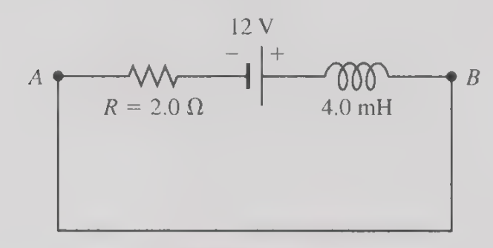

Problem 2
An AC generator with an rms emf of 15.0 V is connected in series with a 0.54-H inductor. The frequency of the source emf is 70.0 Hz. (a) What is the inductive reactance of the circuit? (b) Write an expression for the potential difference across the inductor as a function of time.

Problem 3
A 45.0-V battery with an internal resistance of 13.0 Ohms is connected to a 7.40-H inductor. The current is zero at t = 0. At what rate is the current in the inductor increasing at a. t = 0 and b. t = 2.00 s?

