Name ________________________
PHY2049C, Quiz 6

A- Read all the quiz once, or twice, before beginning to write. Make sure to comprehend all questions and start with those you feel most confident in.
B – Be clear and concise. There are no extra points for being verbose or writing extra.
C –Only use the white pages that I will provide. You have 50 minutes to answer the quiz.
---------------------------------------------------------------------------------------------------------------------------
Problem 1
The Figure shows four arrangements in which long parallel wires carry equal currents directly into or out of the page at the corners of identical squares. Rank the arrangements according to the magnitude of the net magnetic field at the center of the square, greatest first.
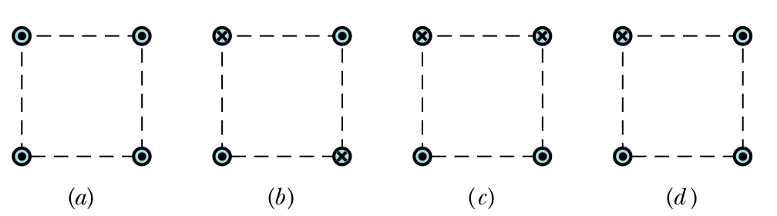
Problem 2
The figure (left) shows four circular Amperian loops (a, b, c, d) and, in cross section, four long circular conductors (the shaded a regions), all of which are concentric. Three of the conductors are hollow cylinders; the central conductor is a solid cylinder. The currents in the conductors are, from smallest radius to largest radius, 4 A out of the page, 9 A into the page, 5 A out of the page, and 3 A into the page. Rank the Amperian loops according to the magnitude of B around each, greatest first.
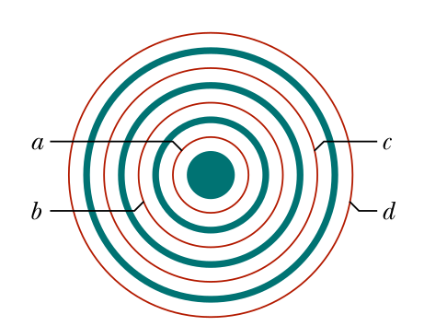
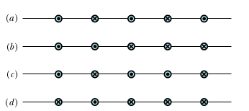

Problem 3
The Figure (right) shows four arrangements in which long, parallel, equally spaced wires carry equal currents directly into or out of the page. Rank the arrangements according to the magnitude of the net force on the central wire due to the currents in the other wires, greatest first.

Problem 4
A ring of radius R with line charge density λ rotates about its axis at angular speed ω. What is the magnetic field at the center of the ring?

