Name ________________________ PHY2049C, Quiz 7

A- Read all the quiz once, or twice, before beginning to write. Make sure to comprehend all questions and start with those you feel most confident in.
B – Be clear and concise. There are no extra points for being verbose or writing extra.
C –Only use the white pages that I will provide. You have 60 minutes to answer the quiz.
---------------------------------------------------------------------------------------------------------------------------
Problem 1 The current I in a long, straight wire is constant and is directed toward the right as in the figure. Conducting loops A, B, C, and D are moving, in the directions shown, near the wire. What is the net force on loop A due to the main wire and loop C’s current. If C has a current, assume only the closest side of loop C affects A and take it to be an infinite wire. The side of the small squares is 1cm.

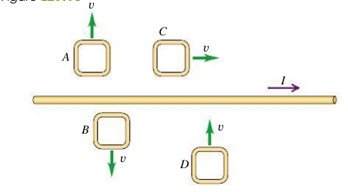

2cm

1cm

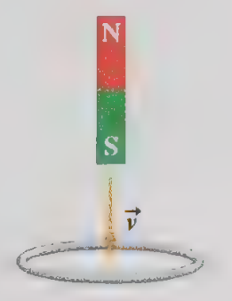
Problem 2 A bar magnet is dropped through a loop of wire as shown in the figure. Sketch a plot (Exact y-axis values do not matter but shape of the plot does) of the induced current over time. Counterclockwise is positive

Problem 3
There were 35 apples, 10 oranges and 77 grapes in a basket, and 4 empty baskets. How do you distribute the oranges, apples and grapes (they must be whole) so that the baskets are as similar as possible? (The amount of apple, oranges and grapes each basket contains is as similar as possible).

