Name ________________________ PHY2049C, Quiz 2

A- Read all the quiz once, or twice, before beginning to write. Make sure to comprehend all questions and start with those you feel most confident in.
B – Be clear and concise. There are no extra points for being verbose or writing extra.
C –Only use the white pages that I will provide. You have 50 minutes to answer the quiz.
---------------------------------------------------------------------------------------------------------------------------
Problem 1
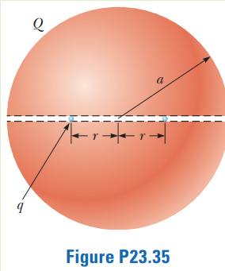
You are working for the summer at a research laboratory. Your research director has devised a scheme for holding small charged particles at fixed positions. The scheme is shown in Figure P23.35. A large insulating sphere of radius a carries a total positive charge Q with a uniform volume charge density. A very thin tunnel is drilled through a diameter of the sphere and two small spheres with charge q are placed in the tunnel. These spheres are represented by the blue dots in the figure. They find equilibrium positions at a distance of r on either side of the center of the sphere. Your research director has had great success with this scheme. Determine the specific value of r at which equilibrium exists. (Hint: ignore the small tunnel, what is the electric field inside a solid field? We did this in class. Add this field to the field of the other small sphere.)

Problem 2
A sphere of radius R surrounds a particle with charge Q located at its center as shown in Figure P23.43. Find the electric flux through a circular cap of half-angle θ.
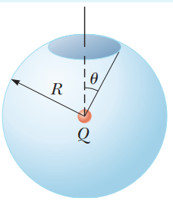

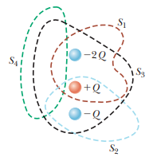

Problem 3
Rank the surfaces in terms of their electric flux, greatest first.

