Name ________________________
PHY2049C, Quiz 8

A- Read all the quiz once, or twice, before beginning to write. Make sure to comprehend all questions and start with those you feel most confident in.
B – Be clear and concise. There are no extra points for being verbose or writing extra.
C –Only use the white pages that I will provide. You have 50 minutes to answer the quiz.
---------------------------------------------------------------------------------------------------------------------------
Rank in order, from largest to smallest, the total impedance Za to Zc for the three circuits in the figure

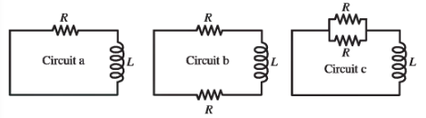

In the circuit shown in the figure, the capacitor has capacitance C = 10 mF and is initially charged
to 100 V with the polarity shown. The resistor R₀ has resistance 10 Ω. At time t = 0 the switch S
is closed. The small circuit is not connected in any way to the large one. The wire of the small circuit has a resistance of 1.0 Ω and contains 25 loops. The large circuit is a rectangle 2.0 m by 4.0 m, while the small one has dimensions a = 10.0 cm and b = 20.0 cm. The distance c is 5.0 cm. (The figure is not drawn to scale.) Both circuits are held stationary. Assume that only the wire nearest the small circuit produces an appreciable magnetic field through it.

(a) In what direction will the current in the small circuit flow?
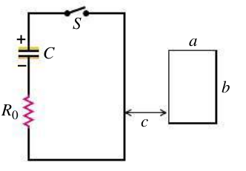

(b) Consider now the figure to the right, where we ground the small loop. In which direction will the current flow?
Problem 3
Find the current in the small circuit 100 ms after S is closed for the case above (left figure).

