Name ________________________
PHY2049C, Quiz 8

A- Read all the quiz once, or twice, before beginning to write. Make sure to comprehend all questions and start with those you feel most confident in.
B – Be clear and concise. There are no extra points for being verbose or writing extra.
C –Only use the white pages that I will provide. You have 50 minutes to answer the quiz.
----------------------------------------------------------------------------------------------------------------------------
Problem 1
The current in a resistanceless inductor is caused to vary with time as shown in the graph of the figure. Sketch the pattern that would be observed on the screen of an oscilloscope connected to the terminals of the inductor.
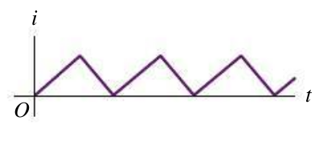

Problem 2
Two inductors L1 and L2 are connected in series and are separated by a large distance so that the
magnetic field of one cannot affect the other. (a) Show that the equivalent inductance is given by

L_{eq} = L1 + L2.

Hint: remember the arguments used to derive equivalent capacitance or resistance in class.

Problem 3
A typical light dimmer used to dim the stage lights in a theater
consists of a variable inductor L (whose inductance is adjustable supply
between zero and Lmax) connected in series with a lightbulb. The
electrical supply is 120 V (rms) at 60.0 Hz; the lightbulb is rated
at 120 V, 1000 W. A) If L is set to 10 H they dim by what factor? B) If L is set to 0 but the frequency is lowered to 20Hz, will this dim the lights more or less than in case A?

