Name ________________________
PHY2049C, Quiz 8

A- Read all the quiz once, or twice, before beginning to write. Make sure to comprehend all questions and start with those you feel most confident in.
B – Be clear and concise. There are no extra points for being verbose or writing extra.
C –Only use the white pages that I will provide. You have 50 minutes to answer the quiz.
----------------------------------------------------------------------------------------------------------------------------

Problem 1
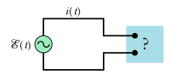
The figure shows an AC generator connected to a “black box” through a pair of terminals. The box contains an RLC circuit, possibly even a multiloop circuit, whose elements and connections we do not know. Measurements outside the box reveal that
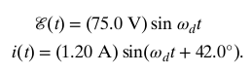

a) is there a capacitor in the box? b) does the current lead or lag the emf? c) is the circuit in resonance?

Problem 2
The figure shows an “autotransformer.” It consists of a single coil (with a core). The core is made of iron which has a magnetic permiability 1150 H/m. Three taps T_{i} are provided. Between taps T1 and T2 there are 200 turns, and between taps T2 and T3 there are 800 turns. Any two taps can be chosen as the primary terminals, and any two taps can be chosen as the secondary terminals. Label the 9 choices like this: P:xy, S:xz where x, y, and z can represent 1, 2 and 3 referring to the taps. Rank these choices for maximum step up to maximum step down voltage.
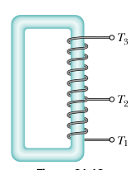

Problem 3
Charges on the capacitors in three oscillating LC circuits vary as:
(1) q = 2 cos 4t, (2) q = 4 cos t, (3) q = 3 cos 4t (with q in coulombs and t in seconds). Rank the circuits according to (a) the current amplitude and (b) the period, greatest first.

