Name ________________________
PHY2049C, Quiz 9

A- Read all the quiz once, or twice, before beginning to write. Make sure to comprehend all questions and start with those you feel most confident in.
B – Be clear and concise. There are no extra points for being verbose or writing extra.
C –Only use the white pages that I will provide. You have 50 minutes to answer the quiz.
----------------------------------------------------------------------------------------------------------------------------
Problem 1
The rather simple circuit shown below is known as a voltage divider. The symbol consisting of three horizontal lines is represents “ground.” The voltage divider is widely used in circuits and a single voltage source can be used to provide reduced voltage to a load resistor as shown in the second part of the figure. (a) What is the output voltage Vout of circuit (a) in terms of R1,R2,andVin? (b) What is the output voltage Vout of circuit (b) in terms of R1,R2,RL,andVin?
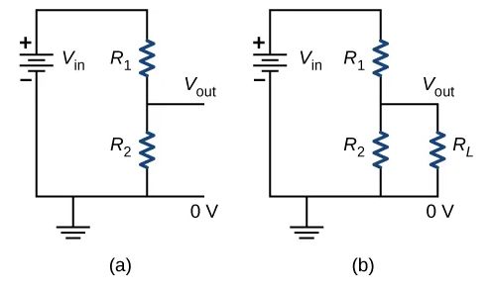

Problem 2
In the circuit shown in the figure, emf = 24.0 V, R1 = 6.00 Ω, R3 = 12.0 Ω, and R2 can vary between E 3.00 Ω and 24.0 Ω. For what value of R2 is the power dissipated by heating element R2 the greatest?
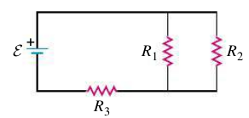

Problem 3
An electric motor connected to a 120 V, 60.0 Hz ac outlet does mechanical work at the rate of 0.100 hp (1 hp = 746 W). If the motor draws an rms current of 0.650 A, what is the torque of the motor?

