Name ________________________
PHY2048C, Quiz 1

A- Read all the quiz once, or twice, before beginning to write. Make sure to comprehend all questions and start with those you feel most confident.
B – Be clear and concise. There are no extra points for being verbose or writing extra.
C –Only use the white pages that I will provide. You have 50 minutes to answer the quiz.
---------------------------------------------------------------------------------------------------------------------------

Problem 1

The figure shows four paths along which objects move from a starting point to a final point, all in the same time interval. The paths pass over a grid of equally spaced straight lines. Rank (using =, <, >) the paths according to (a) the average velocity of the objects and (b) the average speed of the objects, greatest first.
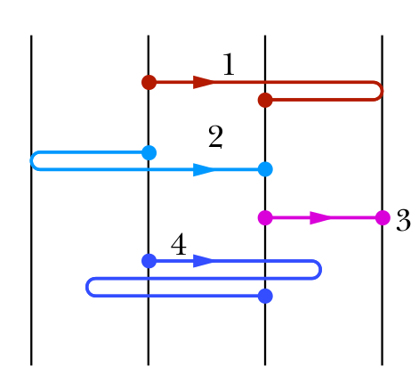
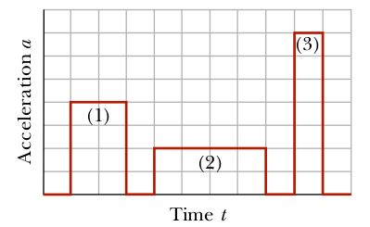
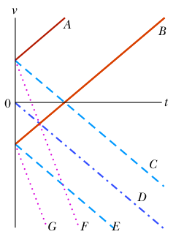

Figure 1 Figure 2
Figure 3
Problem 2

Figure 2 shows that a particle moving along an x axis undergoes three periods of acceleration. Without written computation, rank the acceleration periods according to the increases they produce in the particle’s velocity, greatest first.

Problem 3

Hanging over the railing of a bridge, you drop an egg as you throw a second egg downward. Which curves in Figure 3 give the velocity v(t) for (a) the dropped egg and (b) the thrown egg? (Curves A and B are parallel; so are C, D, and E; so are F and G.)

Problem 4

Anna has 35 eggs in a basket, some brown and some while, and two empty baskets. She fills the empty baskets such that the proportion of brown in basket 1 to white eggs in basket 2 is 4:5. The proportion between the total eggs and to white eggs in basket 1 is 10:2. If the total number of eggs in basket 1 is 11, how many white eggs are in basket 2?

