Name ________________________
PHY2048C, Quiz 1

A- Read all the quiz once, or twice, before beginning to write. Make sure to comprehend all questions and start with those you feel most confident.
B – Be clear and concise. There are no extra points for being verbose or writing extra.
C –Only use the white pages that I will provide. You have 50 minutes to answer the quiz.
---------------------------------------------------------------------------------------------------------------------------

Problem 1

Each of the strobe photographs (a), (b), and (c) in the figure was taken of a single disk moving toward the right, which we take as the positive direction. Within each photograph the time interval between images is constant. Rank (using <, >, =) in terms of (1) acceleration of the ball and (2) initial velocity. (3) For each photograph, prepare graphs of x versus t, v versus t, and a versus t, vertically aligned with their time axes identical, to show the motion of the disk. You will not be able to place numbers other than zero on the axes, but show the correct shapes for the graph lines.
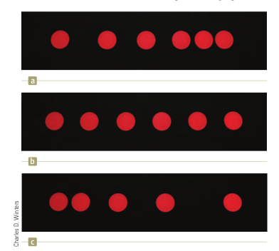

Problem 2

A ball has radius R. Its mass is redistributed into N balls of radii r. What is the ratio between the R and r?

Problem 3

Harvard Bridge, which connects MIT with its fraternities across the Charles River, has a length of 364.4 Smoots plus one ear (an average ear is taken to measure 30 mm, and the bridge is 660 m). The Figure shows three parallel paths, measured in Smoots (S), Willies (W), and Zeldas (Z). What is the length of 50.0 Smoots in (a) Willies and (b) Zeldas?
