Name ________________________
PHY2048C, Quiz 1

A- Read all the quiz once, or twice, before beginning to write. Make sure to comprehend all questions and start with those you feel most confident.
B – Be clear and concise. There are no extra points for being verbose or writing extra.
C –Only use the white pages that I will provide. You have 50 minutes to answer the quiz.
---------------------------------------------------------------------------------------------------------------------------

Problem 1

When a high-speed passenger train traveling at 161 km/h rounds a bend of radius r=30m, the engineer is shocked to see that a locomotive has improperly entered onto the track from a siding and is a distance D = 676 m ahead (Fig. 2.17). The locomotive is moving at 29.0 km/h. The engineer of the high-speed train immediately applies the brakes. (a) What must be the magnitude of the resulting constant deceleration if a collision is to be just avoided?
r
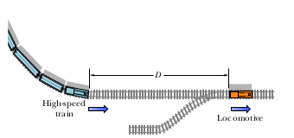

Problem 2

In a school, there are 40 girls and 180 boys. Each of the girls have the same amount of crayons each, and the same of the boys. The girls have 25% of the crayons and the proportion between the crayons of one boy and one girl is three halves. (a) How many crayons does each boy have?

(b) Now 50 crayons are lost, half between the boys and half between the girls. What percentage of the total crayons do the girls now have?

Problem 3

The semiconductor chip at the heart of a personal computer is a square 4 mm on a side and 0.1mm hight, and contains 10⁶ electronic components, each of 0.1mm hight. (a) If each component has a square base, what are the sides of these bases in Bohr radii (0.53 x 10⁻¹⁰ m)? (The Bohr radius is the average distance between an electron an a proton in a room-remperature Hydrogen atom).

