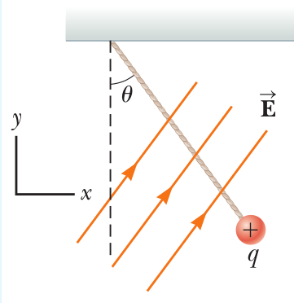
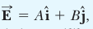
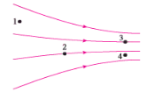
Name ________________________ PHY2049C, Quiz 1

A- Read all the quiz once, or twice, before beginning to write. Make sure to comprehend all questions and start with those you feel most confident.
B – Be clear and concise. There are no extra points for being verbose or writing extra.
C –Only use the white pages that I will provide. You have 50 minutes to answer the quiz.
---------------------------------------------------------------------------------------------------------------------------

Problem 1

A solid gold cone has a radius of 6 inches. It is melted to form smaller gold cones. Each smaller cone has a height of 2 inches and a radius of 1 inch. How many smaller cones can be formed?

Problem 2

Rank in order, from largest to smallest, the electric field strengths E_l to E_4 at points 1 to 4 the figure below, explain. A negative point charge of 1 C is placed to the right of the figure, rank the news E_l to E_4

Problem 3

A charged cork ball of mass m is suspended on a light string in the presence of a uniform electric field as shown in the figure below. When

where A and B are positive quantities, the ball is in equilibrium at the angle θ. Find as a function of A, B, and θ.

