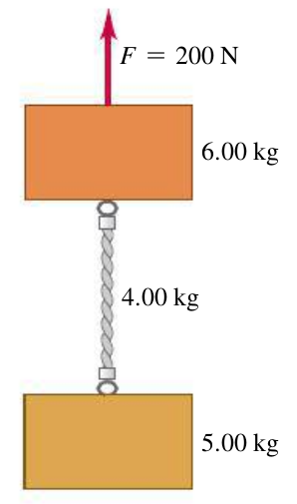
Name ________________________
PHY2018C, Quiz 2

A- Read all the quiz once, or twice, before beginning to write. Make sure to comprehend all questions and start with those you feel most confident.
B – Be clear and concise. There are no extra points for being verbose or writing extra.
C –Only use the white pages that I will provide. You have 50 minutes to answer the quiz.
---------------------------------------------------------------------------------------------------------------------------

Problem 1

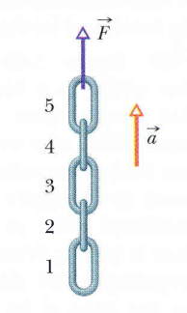
Tara, Nico, and Alex have 500 B./ between the three of them. Tara spent 2/5 of her money. Nico spent 40 B./, and Alex spent twice the amount Tara spent. If all three friends end with the same amount of money each, how much money did Alex had at the beginning?

Problem 2 (From Halliday, Resnik, Walker)

In Figure 1, a chain consisting of five links, each of mass 0.100 kg, is lifted vertically with constant acceleration of magnitude a = 2.50 m/s2. Find the magnitude of the force on link 4 from link 5

Figure 1
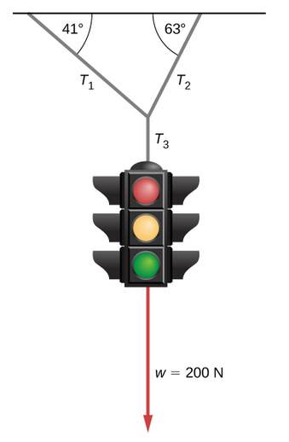
Problem 3 (OpenStax)

The traffic light hangs from the cables as shown. Draw a free-body diagram on a coordinate plane for the joint that unites the 3 massless ropes, represented by
the circle in the figure.

Problem 4

The two blocks in the Figure to the left are connected by
a heavy uniform rope with a mass of 4.00 kg.
An upward force 6.00 kg of 200 N is applied as shown.
Draw three free-body diagrams: one for the
6.00-kg block, one for the 4.00-kg rope,
and another one for the 5.00-kg block.

