Name ________________________
PHY2018C, Quiz 2

A- Read all the quiz once, or twice, before beginning to write. Make sure to comprehend all questions and start with those you feel most confident.
B – Be clear and concise. There are no extra points for being verbose or writing extra.
C –Only use the white pages that I will provide. You have 50 minutes to answer the quiz.
---------------------------------------------------------------------------------------------------------------------------

Problem 1

Tara, Nico, and Alex and Marcus have 600 B./ between the four of them. Marcus has 100 B./ Tara spent 2/5 of her money. Nico spent 40 B./, and Alex spent twice the amount Tara spent. If all three friends that spent money end with the same amount of money each, what’s the proportion between Alex’s original money and Marcus’s?
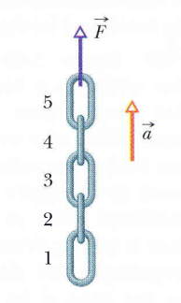

Problem 2 (From Halliday, Resnik, Walker)

In Figure 1, a chain consisting of five links, each of mass 0.327 kg, is lifted vertically with constant acceleration of magnitude a = 9.81 m/s2. (a) Find the magnitude of the force of link 2 on 3. The links break when a force of 30N is applied to them. What’s the minimum acceleration that will break the links and which link will break first?

Figure 1

Problem 3 (OpenStax)

A block starts at rest and slides down a frictionless plane inclined at an angle θ . What should θ be so that the block travels a given horizontal distance in the minimum amount of time?

