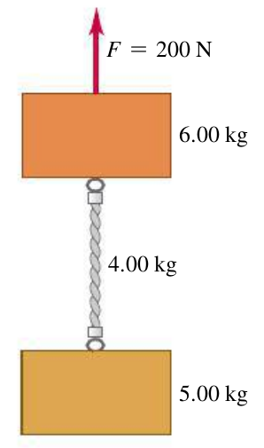
Name ________________________
PHY2048C, Quiz 2

A- Read all the quiz once, or twice, before beginning to write. Make sure to comprehend all questions and start with those you feel most confident.
B – Be clear and concise. There are no extra points for being verbose or writing extra.
C –Only use the white pages that I will provide. You have 50 minutes to answer the quiz.
---------------------------------------------------------------------------------------------------------------------------

Problem 1: Write an algebraic expression for each of the following:

(a) Jon has my stickers. He uses 20 stickers and devices the reminder equally between his two sisters. Find the number of stickers each sister receives.

(b) 2/5 of Abel’s book are equal to 4/7 of Bella’s books. Bellas gives x books to Abel and now the proportion between 2/3 of Abel’s book and 2/5 of Bella’s books is 5:4. Solve for the initial number of books in terms of x.

Figure 1
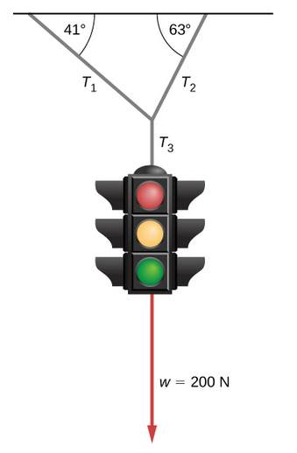
Problem 2 (OpenStax)

The traffic light hangs from the cables as shown which are connected
to a ceiling. Draw a free-body diagram on a coordinate plane for the
ceiling.

Problem 3: A rope with mass.

The two blocks in the Figure to the left are connected by
a heavy uniform rope with a mass of 4.00 kg.
An upward force 6.00 kg of 200 N is applied as shown.
(a) What is the tension at the top of the heavy rope?
(b) What is the tension at the midpoint
of the rope?

