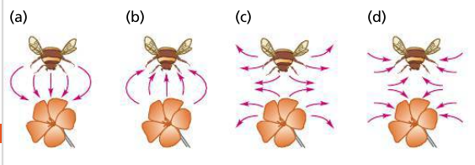
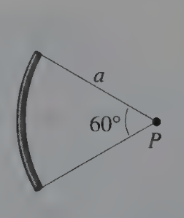
Name ________________________
PHY2049C, Quiz 2

A- Read all the quiz once, or twice, before beginning to write. Make sure to comprehend all questions and start with those you feel most confident.
B – Be clear and concise. There are no extra points for being verbose or writing extra.
C –Only use the white pages that I will provide. You have 50 minutes to answer the quiz.
---------------------------------------------------------------------------------------------------------------------------
Problem 1 (Physics A)

The world’s highest waterfall, the Cherun-Meru in Venezuela, has a total drop of 980 m. (a) How much work does gravity do on a cubic meter of water dropping down the Cherun-Meru? (b) The rate of flow is 14,200 liters per second, what’s the power done by gravity?

Problem 2

A thin, flexible rod carrying charge Q spread uniformly over its length is bent into a circular arc of radius a, as shown in the figure. Find the electric field strength at the point P, which is the center of the circular arc.

Problem 3
After one bee left a flower with a positive charge, that bee flew away and another bee with the same amount of positive charge flew close to the plant. Which diagram best represents the electric field lines between the bee and the flower?

