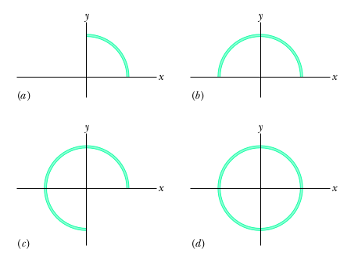
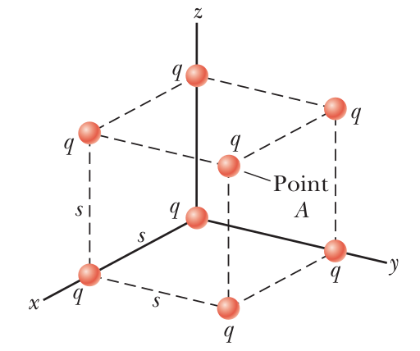
Name ________________________
PHY2049C, Quiz 2

A- Read all the quiz once, or twice, before beginning to write. Make sure to comprehend all questions and start with those you feel most confident.
B – Be clear and concise. There are no extra points for being verbose or writing extra.
C –Only use the white pages that I will provide. You have 60 minutes to answer the quiz.
---------------------------------------------------------------------------------------------------------------------------
Problem 1

In Figure (a) the right a circular plastic rod with uniform charge +Q produces an electric field of magnitude E at the center of curvature (at the origin). In Figures (b), (c), and (d), more circular rods, each with identical uniform charges +Q, are added until the circle is complete. A fifth arrangement (which would be labeled e) is like that in d except the rod in the fourth quadrant has charge −Q. Rank the five arrangements according to the magnitude of the electric field at the center of curvature, greatest first.

Problem 2: Write an algebraic expression from each of the following:

A number is 7 times more than the product of 6 and p

The total cost of 2 boats if 7 boats cost a total of y Balboas

Jacob has m nails and twice as many bolts as nails. He buys another 20 nails and 30 bolts. Find the total number of nails and bolts Jacob has now.

Problem 3
Eight charged particles, each of magnitude q, are located on the corners of a cube of edge s as shown the figure. Find the ratio of the magnitudes of the electric fields E_{A}/E_{B} in points A and B.
Point
B

