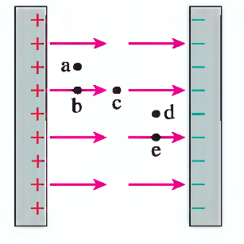
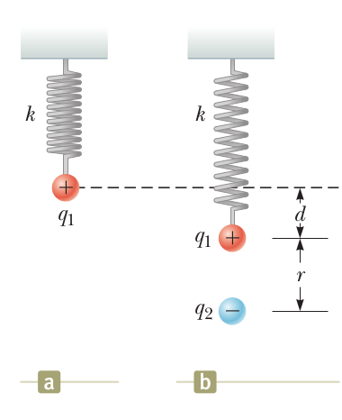
Name ________________________
PHY2049C, Quiz 1

A- Read all the quiz once, or twice, before beginning to write. Make sure to comprehend all questions and start with those you feel most confident.
B – Be clear and concise. There are no extra points for being verbose or writing extra.
C –Only use the white pages that I will provide. You have 60 minutes to answer the quiz.
---------------------------------------------------------------------------------------------------------------------------
Problem 1

A small sphere of charge q = 0.800 mC hangs from the end of a spring as in Figure a. When another small sphere of charge q = 600 mC is held beneath the first sphere as in Figure b, the spring stretches by d = 3.50 cm from its original length and reaches a new equilibrium position with a separation between the charges of r = 5.00 cm. What is the force k constant of the spring?

Problem 2

Jenny, Sara and Ricardo have a total of 3000 balboas divided in peso coins (50 cents). The proportion of coins between Ricardo and Jenny is 5:2. Sara gives 1000 coins to Jenny, and now the proportion of Balboas between Ricardo and Jenny is 5:3. What’s the initial amount of coins that Sara had?

Problem 3

Rank in order, from largest to smallest, the forces Fa to Fe a proton would experience if placed at points a to e in this parallel-plate capacitor.

