Name ________________________ PHY2049C, Quiz 3

A- Read all the quiz once, or twice, before beginning to write. Make sure to comprehend all questions and start with those you fell most confident.
B – Be clear and concise. There are no extra points for being verbose or writing extra.
C –Only use the white pages that I will provide. You have 50 minutes to answer the quiz.
---------------------------------------------------------------------------------------------------------------------------
Problem 1
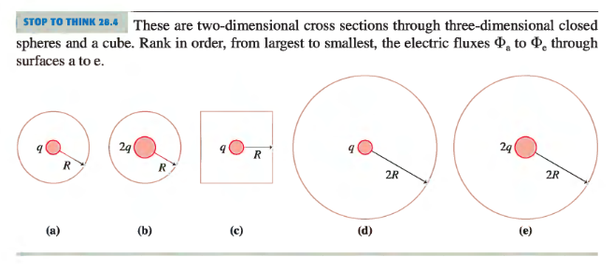
There are two-dimensional cross sections (the center circle) through three-dimensional closed spheres and a cube (the outer shapes). Rank in order, from largest to smallest, the electric fluxes Φa to Φe through surfaces a to e.

Problem 2a
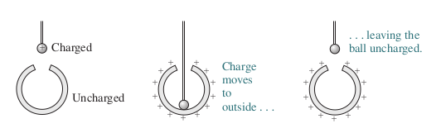
Consider these situations(a, b, c, d, and e, in order):

The string holding the ball is insulating and the ball and the shell are conductors. The orifice of the shell in negligible. Rank the situation in terms of the magnitude of the electrostatic force on the ball.

Problem 2b
The charge of the metallic ball of radius 1mm (in situation a above) is 6.3 mC, and the radius of the hollow sphere is 20 cm. In situation b they touch and the ball is completely discharged. What is the surface charge density of the hollow sphere? What was the volume charge density of the small ball?

Problem 3a (Physics A)
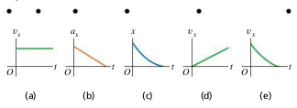
The black dots at the top of the figure below represent a series of high-speed photographs of an insect flying in a straight line from left to right (in the positive x-direction). The time intervals between the photos are the same. Which of the graphs in the figure most plausibly depicts this insect’s motion?

Problem 3b
Anya has 2p trading cards. Ben has three times as many trading cards as Anya. Colin has half as many trading cards as Ben. Find the total number of trading cards they have altogether in terms of p.

