Name ________________________
PHY2048C, Quiz 5

A- Read all the quiz once, or twice, before beginning to write. Make sure to comprehend all questions and start with those you feel most confident in.
B – Be clear and concise. There are no extra points for being verbose or writing extra.
C –Only use the white pages that I will provide. You have 50 minutes to answer the quiz.
---------------------------------------------------------------------------------------------------------------------------
Problem 1 (Halliday, Resnik, Walker)

Figure 1 shows three situations in which the same horizontal rod is supported by a hinge on a wall at one end and a cord at its other end. Without written calculation, rank the situations according to the magnitudes of (a) the force on the rod from the cord, (b) the vertical force on the rod from the hinge, and (c) the horizontal force on the rod from the hinge, greatest first.
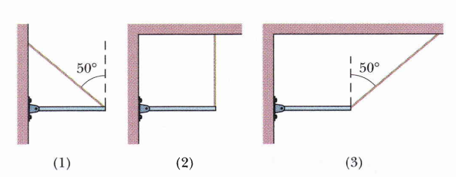

Figure 1
Problem 2

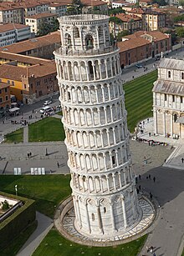
The leaning Tower of Pisa currently leans at a 3.97° angle to the vertical. Treating the tower as a solid cylinder, what is the maximum angle at which it can lean before falling over? Treat the tower as a uniform cylinder 7.0 m in diameter and 55 m high, and assume the ground supports the tower’s weight but does not provide any torque. In 1990, the tower reached a peak leaning angle of 5.5° (according to florence-museum.com) which caused concerns of instability, thereby starting a stabilization project that set the tower at the current 3.97° angle. Towerofpisa.org, however, claims that the peak inclination in 1990 was 10°. Based on your calculation. Which claim has more credibility?

Problem 3 (Inequalities)
Al, Dick, Jack, and Tom were counting up the results of a day's fishing:

Tom had caught more than Jack.
Between them, Al and Dick had caught just as many as Jack and Tom.
Al and Tom had not caught as many as Dick and Jack.
Rank them in terms of who caught more fish. Greatest first.

