Name ________________________
PHY2048C, Quiz 5

A- Read all the quiz once, or twice, before beginning to write. Make sure to comprehend all questions and start with those you feel most confident in.
B – Be clear and concise. There are no extra points for being verbose or writing extra.
C –Only use the white pages that I will provide. You have 60 minutes to answer the quiz.
---------------------------------------------------------------------------------------------------------------------------

Problem 1

Six forces are applied to the door in the figure. Rank in order, from largest to smallest, the six corresponding torques about the hinge on the left end of the door. Explain your ranking.

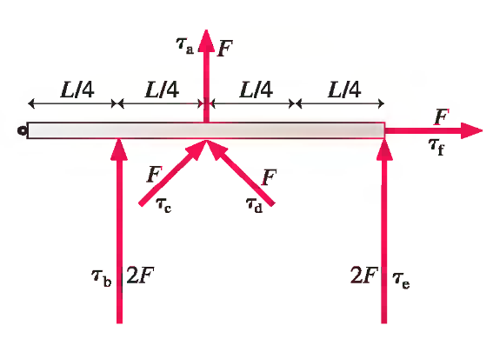
Problem 2

Four spotted cows and three brown cows give as much milk in five days as three spotted cows and five brown cows give in four days. (a) Which kind of cow is the better milker, spotted or brown? (b) What is the ratio between their daily milk production?

Problem 3

What horizontal force applied at its highest point is necessary to keep a wheel of mass M from rolling or slipping down a slope inclined at angle of 6° to the horizontal?

