Name ________________________
PHY2048C, Quiz 5

A- Read all the quiz once, or twice, before beginning to write. Make sure to comprehend all questions and start with those you feel most confident in.
B – Be clear and concise. There are no extra points for being verbose or writing extra.
C –Only use the white pages that I will provide. You have 50 minutes to answer the quiz.
---------------------------------------------------------------------------------------------------------------------------
Problem 1
A uniform beam of length L and mass m shown in the figure is inclined at an angle θ to the horizontal. Its upper end is connected to a wall by a rope, and its lower end rests on a rough, horizontal surface. The coefficient of static friction between the beam and surface is μ_{S} Assume the angle θ is such that the static friction force is at its maximum value. (a) Draw a force diagram for the beam. (b) Using the condition of rotational equilibrium, find an expression for the tension T in the rope in terms of m, g, and θ.
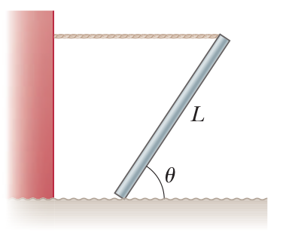

Problem 2
A 60-kg uniform board 2.4 m long is supported by a pivot 80 cm from the left end and by a scale at the right end (Fig. 12.14). How far from the left end should a 40-kg child sit for the scale to read zero?

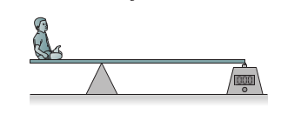

Problem 1
A 4.2-m-long beam is supported by a cable at its center. A 65-kg steelworker stands at one end of the beam, and a 180-kg bucket on the other side of the beam (note that it cannot be at the end since this wouldn’t be in equilibrium). Draw a free-body diagram of the situation.

