Name ________________________ PHY2048C, Quiz 5

A- Read all the quiz once, or twice, before beginning to write. Make sure to comprehend all questions and start with those you feel most confident in.
B – Be clear and concise. There are no extra points for being verbose or writing extra.
C –Only use the white pages that I will provide. You have 50 minutes to answer the quiz.
---------------------------------------------------------------------------------------------------------------------------
Problem 1
Three identical books of length L are stacked over the edge of a table as shown in Fig. 12.29. The top book overhangs the middle one by L/2, so it just barely avoids falling. The middle book overhangs the bottom one by L/4. How much of the bottom book can overhang the edge of the table without the books falling? (Consider the torques on the bottom book due to the upper books. The Normal Force of the upper books effectively acts in the middle of their surface of contact)
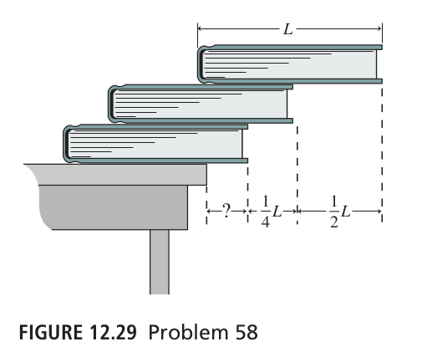

Problem 2
What magnitude of (constant) force F applied horizontally at the axle of the wheel is necessary to raise
the wheel over a step obstacle of height h = 3.00 cm? The wheel’s radius is r = 6.00 cm, and its mass is m = 0.800 kg.
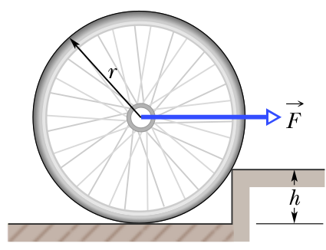

Problem 3
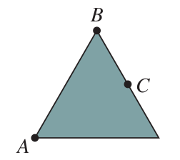
Consider a uniform square plate with 3 potential axis of rotation (A, B, C). (a) Rank according the gravitational torque experienced about each of the axis. (b) Do the same for the triangle.
