Name ________________________ PHY2048C, Quiz 5
A- Read all the quiz once, or twice, before beginning to write. Make sure to comprehend all questions and start with those you feel most confident in.
B – Be clear and concise. There are no extra points for being verbose or writing extra.
C –Only use the white pages that I will provide. You have 50 minutes to answer the quiz.
---------------------------------------------------------------------------------------------------------------------------
Problem 1
In the figure, a uniform sphere of mass m = 0.85 kg and radius r = 4.2 cm is held in place by a massless rope attached to a frictionless wall a distance L = 8.0 cm above the center of the sphere. Find (a) the
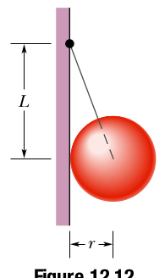
tension in the rope and (b) the force on the sphere from the wall.

Problem 2
A massless rod that leans to the left at an angle 45◦ above the horizontal is supported on the ground by a pivot and at its midpoint by a horizontal cable that is anchored on the wall to its right. Make a drawing of the situation and a free-body diagram of the rod.

Problem 3
Draw a modified free-body diagram for the bottle-holder
system shown in the figure. (Draw a diagram for the bottle and for the bottle-holder)
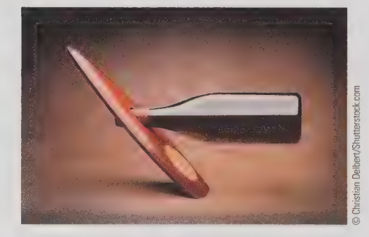

Problem 4: Which of these bodies (a, b, c, d, and e) are in equilibrium?
