Name ________________________
PHY2049C, Quiz 5

A- Read all the quiz once, or twice, before beginning to write. Make sure to comprehend all questions and start with those you fell most confident.
B – Be clear and concise. There are no extra points for being verbose or writing extra.
C –Only use the white pages that I will provide. You have 50 minutes to answer the quiz.
---------------------------------------------------------------------------------------------------------------------------
Problem 1

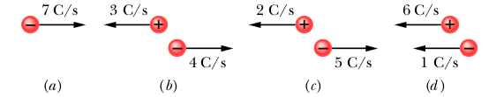
The figure shows four situations in which positive and negative charges move horizontally and gives the rate at which each charge moves. Rank the situations according to the effective current through the regions, greatest first.

Problem 2

The figure gives the electric potential V(x) versus position x along a copper wire carrying current. The wire consists of three sections that differ in radius. Rank the three sections according to the magnitude of the (a) electric field and (b) current density, greatest first.
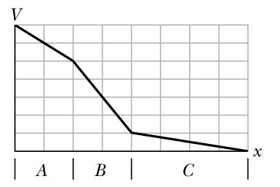

Problem 3

A uniform wire of resistance R is stretched until its length doubles. Assuming its density and resistivity remain constant, what’s its new resistance?

