Name ________________________ PHY2048C, Quiz 6

A- Read all the quiz once, or twice, before beginning to write. Make sure to comprehend all questions and start with those you feel most confident in.
B – Be clear and concise. There are no extra points for being verbose or writing extra.
C –Only use the white pages that I will provide. You have 60 minutes to answer the quiz.
---------------------------------------------------------------------------------------------------------------------------
Problem 1
A solid marble starts from rest and rolls without slipping on the loop-the-loop track in the figure below. Find the minimum starting height from which the marble will remain on the track through the loop. Assume the marble’s radius is small compared with R
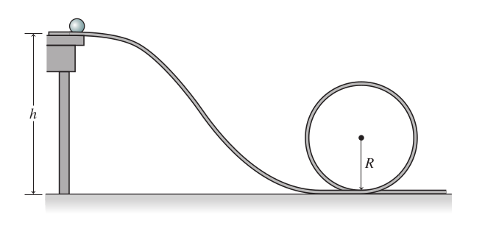

Problem 2
In the figure, a disk, a hoop, and a solid sphere are made to spin about fixed central axes (like a top) by means of strings wrapped around them, with the strings producing the same constant tangential force F on all three objects. The three objects have the same mass and radius, and they are initially stationary. Rank the objects according to (a) their angular momentum about their central axes and (b) their angular speed, greatest first, when the strings have been pulled for a certain time t.
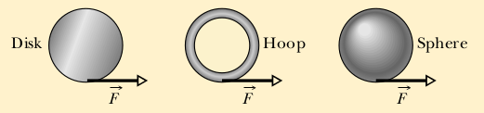
Problem 3
The figure shows an overhead view of a rectangular slab that can spin like a merry-go-round about its center at O. Also shown are seven paths along which wads of bubble gum can be thrown (all with the same speed and mass) to stick onto the stationary slab. (a) Rank the paths according to the angular speed that the slab (and gum) will have after the gum sticks, greatest first.

