Name ________________________ PHY2048C, Quiz 5

A- Read all the quiz once, or twice, before beginning to write. Make sure to comprehend all questions and start with those you feel most confident in.
B – Be clear and concise. There are no extra points for being verbose or writing extra.
C –Only use the white pages that I will provide. You have 50 minutes to answer the quiz.
---------------------------------------------------------------------------------------------------------------------------
Problem 1
Rank, greatest first, the rotational inertia of a square frame (make by 4 thin rods on length L? about these three axis (you can compute the moments of inertia or do it by eye).

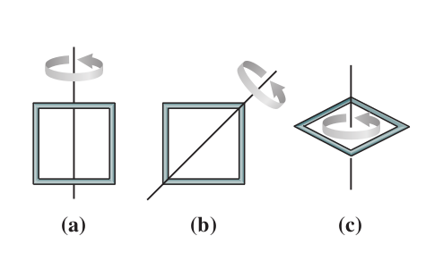

Problem 2
A ball starts from rest and rolls without slipping down a slope, then starts going up a frictionless slope.
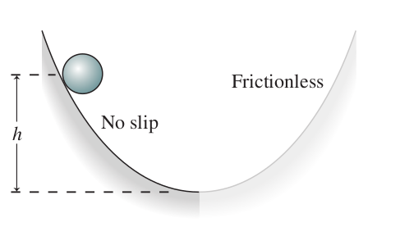
What’s the maximum hight it reaches on the frictionless slope? (Hint: use conservation of energy but note that whatever rotational kinetic energy the ball might get going down will not contribute to the hight going up because there is no friction so the ball will keep its rotational kinetic energy all the way up)

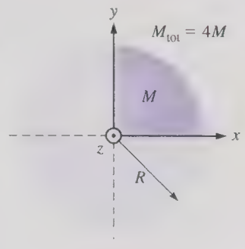

Problem 3
Suppose a disk having mass
M,. and radius R is broken into
four equal parts. What is the rotational inertia of
one-fourth of the disk around
the z axis shown?

