Name ________________________ PHY2048C, Quiz 6

A- Read all the quiz once, or twice, before beginning to write. Make sure to comprehend all questions and start with those you feel most confident in.
B – Be clear and concise. There are no extra points for being verbose or writing extra.
C –Only use the white pages that I will provide. You have 60 minutes to answer the quiz.
---------------------------------------------------------------------------------------------------------------------------
Problem 1
Ideal Zorro (mass M, no height), standing at the edge of a cliff of height H, swings down on a vine of length L and mass m_{v}, grabs a kid of mass m (zero height, standing on the ground), and barely reaches safety at a height h, as depicted in the Figure. Relate H to the other parameters. What is H in meters if
L = 40m, M = 100kg, h = 6m, m = 30kg, m_{v =} 1kg?

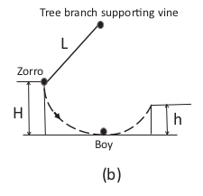

Problem 2
A car is headed north at 70 km/h. Give the magnitude and direction of the angular velocity of its 62-cm-diameter wheels.

Problem 3
When a star like our Sun exhausts its fuel, thermonuclear reactions in its core cease, and it collapses to become a white dwarf. Often the star will blow off its outer layers and lose some mass before it collapses. Suppose a star with the Sun’s mass and radius is rotating with period 25 days and then it collapses to a white dwarf with 60% of the Sun’s mass and a rotation period of P=131 s. (a) What’s the radius of the white dwarf? (b) What is this in terms of the radius of the Earth?

