Name ________________________
PHY2048C, Quiz 7

A- Read all the quiz once, or twice, before beginning to write. Make sure to comprehend all questions and start with those you feel most confident in.
B – Be clear and concise. There are no extra points for being verbose or writing extra.
C –Only use the white pages that I will provide. You have 60 minutes to answer the quiz.
---------------------------------------------------------------------------------------------------------------------------

Problem 1

For the following pair of numbers, give (a) their polar form, (b) their
complex conjugates, (c) their moduli, (d) their quotient z1 /z2 :

z1 = (1+i)/√2
z2 = √3 − i

Problem 2
Show that the critically damped solution of the harmonic oscillator
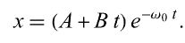
will never turn negative if it starts from rest with some positive x(0).

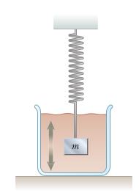
Problem 3

Consider the damped oscillator illustrated in the figure
The mass of the object is 375 g, the spring constant is
100 N/m, and b 5 0.100 N ? s/m. (a) Over what time interval
does the amplitude drop to half its initial value?

