Name ________________________
PHY2048C, Quiz 7

A- Read all the quiz once, or twice, before beginning to write. Make sure to comprehend all questions and start with those you feel most confident in.
B – Be clear and concise. There are no extra points for being verbose or writing extra.
C –Only use the white pages that I will provide. You have 60 minutes to answer the quiz.
---------------------------------------------------------------------------------------------------------------------------

Problem 1

Show that that a driven oscillator has its maximum amplitude of vibration at a frequency

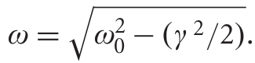

Hint: you have to extremize Z² with respect to omega

Problem 2

Problem 3

A 2kg mass is connected to a spring with k = 400 Nm . The value of the damping coefficient is γ = 1s −1 . It is driven by a force F(t) = 10 cos(10t)N . What is the resonant frequency ω0?

