Name ________________________ PHY2049C, Quiz 7

A- Read all the quiz once, or twice, before beginning to write. Make sure to comprehend all questions and start with those you fell most confident.
B – Be clear and concise. There are no extra points for being verbose or writing extra.
C –Only use the white pages that I will provide. You have 50 minutes to answer the quiz.
---------------------------------------------------------------------------------------------------------------------------
Problem 1 (Wolfson and Passachoff)

A wire carrying 1.5 A passes through a 48-mT magnetic field. The wire is perpendicular to the field and makes a quarter-circle turn of radius 21 cm in the field region, as shown in the figure. Find the magnitude and direction of the magnetic force on the curved section of wire.
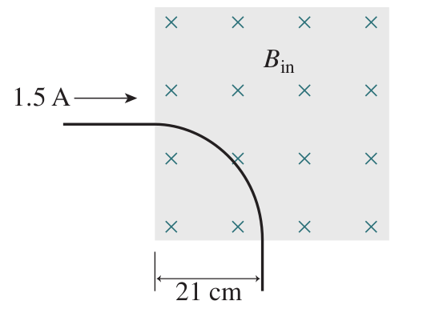
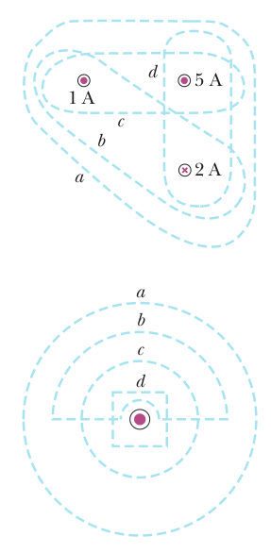

Problem 2a

​Rank the magnitudes of ∫B.ds for the closed paths a through d in the Figure on the top right, from greatest to least.

Problem 2b

Rank the magnitudes of ∫B.ds for the closed paths a through d in the Figure on the bottom right, from greatest to least.

Problem 3

(a) Rank the current loops below (seen edge-on) in terms of the
torque they experience; (b) in terms of the force they experience

