Name ________________________ PHY2049C, Quiz 6

A- Read all the quiz once, or twice, before beginning to write. Make sure to comprehend all questions and start with those you fell most confident.
B – Be clear and concise. There are no extra points for being verbose or writing extra.
C –Only use the white pages that I will provide. You have 50 minutes to answer the quiz.
---------------------------------------------------------------------------------------------------------------------------
Problem 1 (Wolfson and Passachoff)
The Figure below and left represents a snapshot of the velocity vectors of four electrons near a wire carrying current i. The four velocities have the same magnitude; v2 is directed into the page. Electrons 1 and 2 are at the same distance from the wire, as are electrons 3 and 4. Rank the electrons according to the magnitudes of the magnetic forces on them due to current i, greatest first.
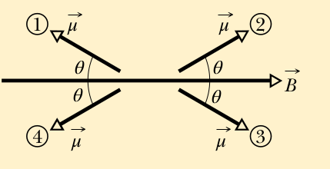
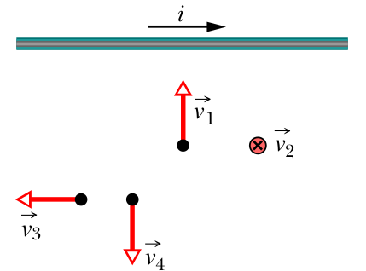

Problem 2
​The figure above and right shows four orientations, at angle θ, of a magnetic dipole moment μ in a magnetic field. Rank the orientations according to (a) the magnitude of the torque on the dipole and (b) the orientation energy of the dipole, greatest first.
Problem 3

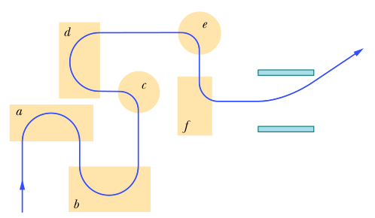
The figure to the left shows the path of a particle through six regions of uniform magnetic field, where the path is either a half-circle or a quarter-circle. Upon leaving the last region, the particle travels between two charged, parallel plates and is deflected toward the plate of higher potential. Rank the field from most positive to most negative, where positive if pointing out of the page.

Problem 4
Two infinite wires carry currents I_{x} and I_{y} along the x and y axes. What is B at a point (x, y)?

