Name ________________________
PHY2049C, Quiz 8

A- Read all the quiz once, or twice, before beginning to write. Make sure to comprehend all questions and start with those you feel most confident in.
B – Be clear and concise. There are no extra points for being verbose or writing extra.
C –Only use the white pages that I will provide. You have 50 minutes to answer the quiz.
---------------------------------------------------------------------------------------------------------------------------
Rank in order, from largest to smallest, the three time constants
ra to tc for the three circuits in the figure

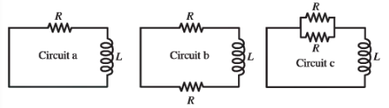

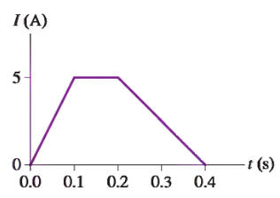

The figure shows the current as a function of time through
a 20-cm-long, 4.0-cm-diameter solenoid with 400 turns. Draw a graph of the induced electric field strength as a function of time at a point 1.0 cm from the axis of the solenoid.

In the figure, a metal rod is forced to move with constant velocity v along two parallel metal rails, connected with a strip of metal at one end. A magnetic field of magnitude B = 0.350 T points out of the page. (a) If the rails are separated by L = 25.0 cm and the speed of the rod is 55.0 cm/s, what emf is generated?

