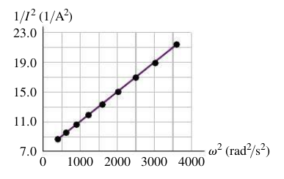
Name ________________________
PHY2049C, Quiz 8

A- Read all the quiz once, or twice, before beginning to write. Make sure to comprehend all questions and start with those you feel most confident in.
B – Be clear and concise. There are no extra points for being verbose or writing extra.
C –Only use the white pages that I will provide. You have 50 minutes to answer the quiz.
---------------------------------------------------------------------------------------------------------------------------
Problem 1
A coworker of yours was making measurements of a large solenoid that is connected to an ac voltage source. Unfortunately, she left for vacation before she completed the analysis, and your boss has asked you to finish it. You are given a graph of 1/(I^2) versus ω^2 (Figure 1), where I is the current in the circuit and v is the angular frequency of the source. A note attached to the graph says that the voltage amplitude of the source was kept constant at 12.0 V. Calculate the inductance of the solenoid.

Problem 2

Problem 3

