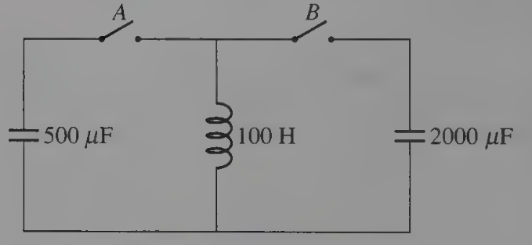
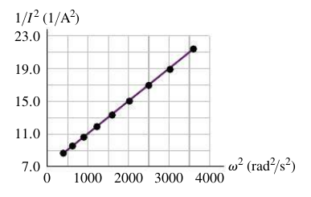
Name ________________________
PHY2049C, Quiz 8

A- Read all the quiz once, or twice, before beginning to write. Make sure to comprehend all questions and start with those you feel most confident in.
B – Be clear and concise. There are no extra points for being verbose or writing extra.
C –Only use the white pages that I will provide. You have 60 minutes to answer the quiz.
---------------------------------------------------------------------------------------------------------------------------
Problem 1
A coworker of yours was making measurements of a large solenoid that is connected to an ac voltage source. Unfortunately, she left for vacation before she completed the analysis, and your boss has asked you to finish it. You are given a graph of 1/(I^2) versus ω^2 (Figure 1), where I is the current in the circuit and v is the angular frequency of the source. A note attached to the graph says that the voltage amplitude of the source was kept constant at 12.0 V. Calculate the inductance of the solenoid.

Problem 2

The 2000-µF capacitor in the figure is initially charged to 200V, (a) Describe how you would manipulate switches A and B to transfer all the energy from the 2000 µF capacitor to the 500 µF capacitor. Include the times you would throw the switches.

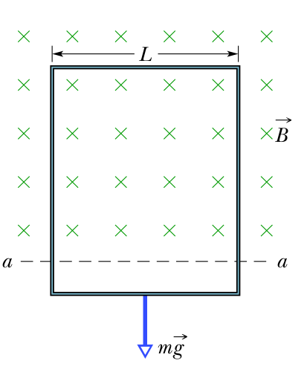

Problem 3

In the figure, a long rectangular conducting loop, of width L, resistance R, and mass m, is hung in a horizontal, uniform magnetic field B that is directed into the page and that exists only above line aa. The loop is then dropped; during its fall, it accelerates until it reaches a certain terminal speed vt due to the fact that the magnetic force increases with the velocity. Ignoring air drag, find an expression for vt.

