Name ________________________ PHY2049C, Quiz 8

A- Read all the quiz once, or twice, before beginning to write. Make sure to comprehend all questions and start with those you feel most confident in.
B – Be clear and concise. There are no extra points for being verbose or writing extra.
C –Only use the white pages that I will provide. You have 50 minutes to answer the quiz.
---------------------------------------------------------------------------------------------------------------------------
Consider the AC circuit in the Figure. The frequency of the AC source is adjusted while its voltage amplitude is held constant. You pass through an AC signal for frequencies (a)f=f_{0,} (b)f=2f_{0 ,}(c)f=0.5f₀
Rank this situations in terms of which one makes the light bulb glow the brightest.
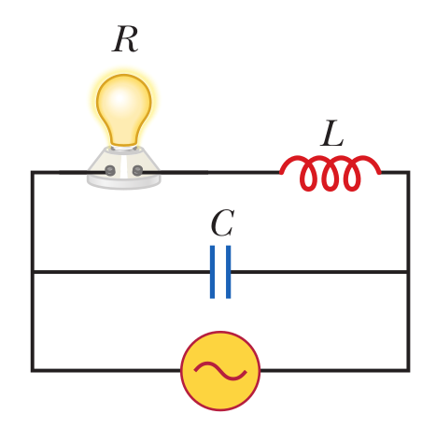
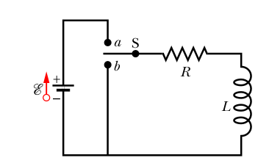

Problem 2
The switch in the circuit of the figure to the right is on a for a very long time when it is then thrown to b. The resulting current through the inductor is indicated in the figure below for four
sets of values for the resistance R and inductance L: (1) R0 and L0, (2) 2R0 and L0, (3) R0 and 2L0, (4) 2R0 and 2L0. Which set goes with which curve?
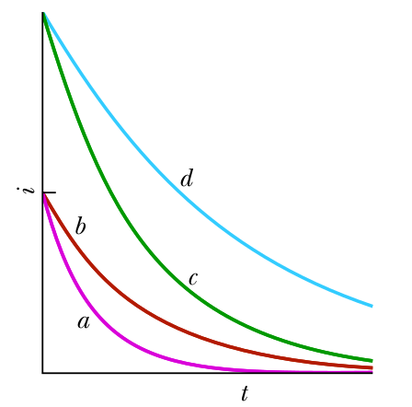

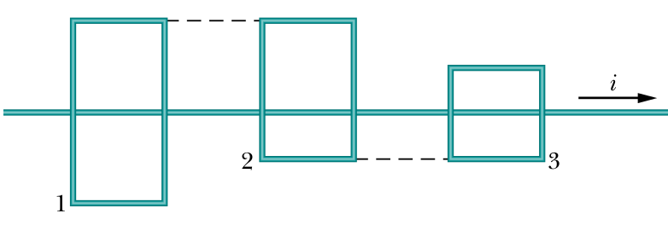

Problem 3
In the figure to the right, a long straight wire with current i passes (without touching) three rectangular wire loops with edge lengths L, 1.5L, and 2L. The loops are widely spaced (so as not to affect one another). Loops 1 and 3 are symmetric about the long wire. Rank the loops according to the size of the current induced in them if current i is (a) constant and (b) increasing

