Name ________________________
PHY2049C, Quiz 5

A- Read all the quiz once, or twice, before beginning to write. Make sure to comprehend all questions and start with those you fell most confident.
B – Be clear and concise. There are no extra points for being verbose or writing extra.
C –Only use the white pages that I will provide. You have 60 minutes to answer the quiz.
---------------------------------------------------------------------------------------------------------------------------
Problem 1
“Relative” is an important word. In the figure, block L of mass m_L = 1.00 kg and block R of mass m_R = 0.500 kg are held in place with a compressed spring between them. When the blocks are released, the spring sends them sliding across a frictionless floor. (The spring has negligible mass and falls to the floor after the blocks leave it.) (a) If the spring gives block L a release speed of 1.20 m/s relative to the floor, how far does block R travel in the next 0.800 s? (b) If, instead, the spring gives block L a release speed of 1.20 m/s relative to the velocity that the spring gives block R, how far does
block R travel in the next 0.800 s?

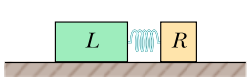

Problem 2
The Figure shows a cubical box that has been constructed from uniform metal plate of negligible thickness. The box is open at the top and has edge length L = 40 cm. Find (a) the x coordinate, (b) the y coordinate, and (c) the z coordinate of the center of mass of the box.

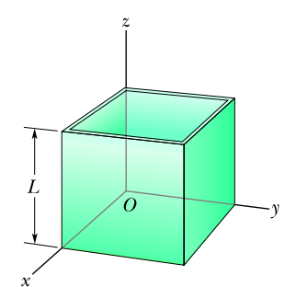

Problem 3
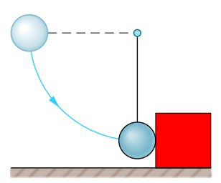
A steel ball of mass 0.500 kg is fastened to a cord that is 70.0 cm long and fixed at the far end. The ball is then released when the cord is horizontal (see the figure). At the bottom of its path, the ball strikes a 2.50 kg steel block initially at rest on a frictionless surface. The collision is perfectly elastic. Finthe speed of the ball after the collision

