Name ________________________PHY2048C, Quiz 6

A- Read all the quiz once, or twice, before beginning to write. Make sure to comprehend all questions and start with those you feel most confident.
B – Be clear and concise. There are no extra points for being verbose or writing extra.
C –Only use the white pages that I will provide. You have 70 minutes to answer the quiz.
---------------------------------------------------------------------------------------------------------------------------
Problem 1 (Halladay, Resnik, Walker)
Forces F1, F2, and F3 act on the structure of Fig. 1 shown in an overhead view. We wish to put the structure in equilibrium by applying a fourth force, at a point such as P a distance d from the axis of rotation O. The fourth force has vector components F_h and F_v. We are given that a = 2.0 m, b = 3.0 m, c = 1.0 m, F1 = 20 N, F2 = 10 N, and F3 = 5.0 N. Find and d.
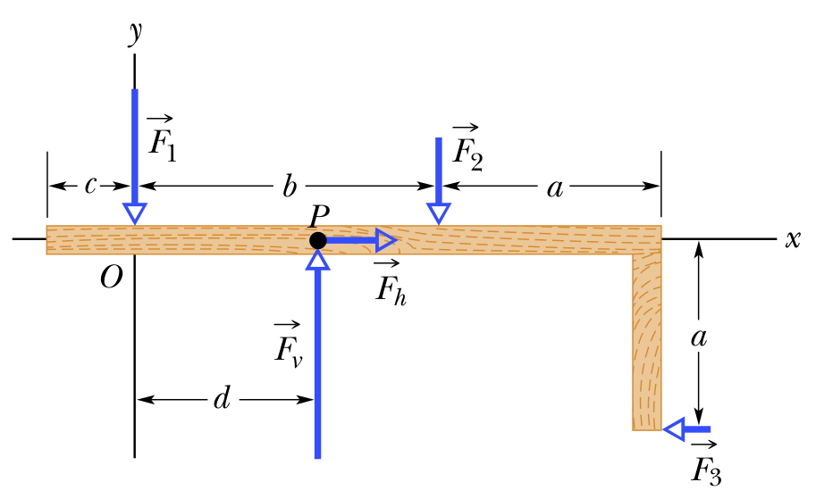

Problem 2
Find the ratio between the angular momentum of Earth about the Sun, (assuming the Earth is a point particle) and the angular momentum of Earth about its own axis (assuming the Earth is a uniform sphere). The distance from the Sun is 1.496*10^8 Km. The radius of the Earth is 6300 Km.

Problem 3
The Figure shows four overhead views of rotating identical uniform disks that are sliding across a frictionless floor. Three forces, of magnitude F, 2F, or 3F, act on each disk, either at the rim, at the center, or halfway between rim and center. Rank with respect to the speed of the red point that lies on the rim of the disk.
