Name ________________________
PHY2049C, Quiz 2

A- Read all the quiz once, or twice, before beginning to write. Make sure to comprehend all questions and start with those you feel most confident.
B – Be clear and concise. There are no extra points for being verbose or writing extra.
C –Only use the white pages that I will provide. You have 50 minutes to answer the quiz.
---------------------------------------------------------------------------------------------------------------------------
Problem 1
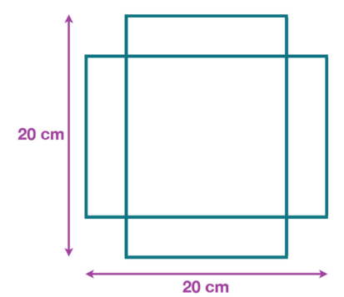
You can make an open box from a 20 by 20 cm piece of paper by cutting out four squares and folding the flaps. What is the biggest volume of box you can make this way?

Problem 2 (Halliday, Resnik, Walker)

Figure 1 shows four situations in which five charged particles are evenly spaced along an axis. The charge values are indicated except for the central particle, which has the same charge in all four situations. Rank the situations according to the magnitude of the net electrostatic force on the central particle, greatest first.
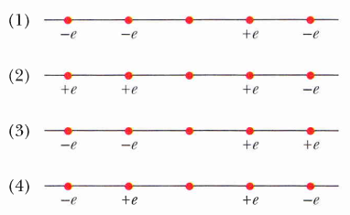

Figure 1

Problem 3

A positive charge Q is uniformly distributed around a semicircle of radius a as shown in Fig. 2. Find the magnitude and direction of the resulting electric field at point P, the center of curvature of
the semicircle.

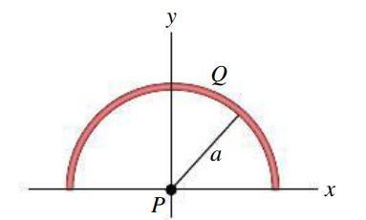Figure 2

