Name ________________________
PHY2018C, Quiz 2

A- Read all the quiz once, or twice, before beginning to write. Make sure to comprehend all questions and start with those you fell most confident.
B – Be clear and concise. There are no extra points for being verbose or writing extra.
C –Only use the white pages that I will provide. You have 50 minutes to answer the quiz.
---------------------------------------------------------------------------------------------------------------------------

Problem 1

(a) Tara, Nico, and Alex have 500 B./ between the three of them. Tara spent 2/5 of her money. Nico spent 40 B./, and Alex spent twice the amount Tara spent. If all three friends end with the same amount of money each, how much money did Alex had at the beginning?
(b) Hector has a total of 30 red and blue balls in his bowling court. Each red ball weights 8 lb, and each blue ball weights 9 lb. If the total weight for all blue balls is 49 lb more than the total weigh for all red balls, how many red balls are there?

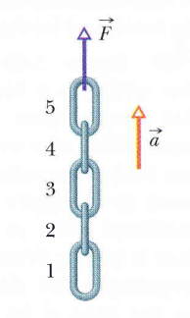

Problem 2 (From Halliday, Resnik, Walker)

In Fig. 1., a chain consisting of five links, each of mass 0.100 kg, is lifted vertically with constant acceleration of magnitude a = – 2.50 m/s². Find the magnitudes of (a) the force on link 1 from link 2, (b) the force on link 2 from link 3, (c) the force on link 3 from link 4, and (d) the force on link 4 from link 5. Then find the magnitudes of (e) the force F on the top link from the person lifting the chain and (f) the net force accelerating each link.

Figure 1

Problem 3 (Sears and Zemansky)

A small SpaceX rocket with mass 20.0 kg is moving in free fall toward the earth. Air resistance can be neglected. When the rocket is 80.0 m above the surface of the earth, it is moving downward with a speed of 30.0 m/s. At that instant the rocket engines start to fire and produce a constant upward force F on the rocket. Assume the change in the rocket’s mass is negligible. What is the value of F if the rocket’s speed becomes zero just as it reaches the surface of the earth, for a soft landing?

