Name ________________________
PHY2018C, Practice Quiz 2

A- Read all the quiz once, or twice, before beginning to write. Make sure to comprehend all questions and start with those you fell most confident.
B – Be clear and concise. There are no extra points for being verbose or writing extra.
C –Only use the white pages that I will provide. You have 50 minutes to answer the quiz.
---------------------------------------------------------------------------------------------------------------------------
Problem 1

Silvia spends 5 times as much as Carlos. Silvia spent B./948 more than Carlos. (a) What is the ratio of the amount of money Silvia spent to the amount of total money they spent together? (b) How much did Carlos and Silvia spent each?

Dean has some local and foreign stamps. The ratio of the number of local stamps to the number of foreign stamps is 3:4. He gave away 28 foreign stamps, and hence the ratio between the number of local stamps to foreign stamps became 9:8 (c) How many local stamps did Dean had at the beginning? (d) how many foreign stamps does Dean have in the end.

Problem 2

There are two forces acting on the 2.00 kg box in the overhead view of Fig. 1, but only one is shown. For , a = 13.0 m/s², and . (a) Find the second force in unit-vector notation and as (b) a magnitude and (c) an angle relative to the positive direction of the x-axis.
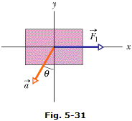

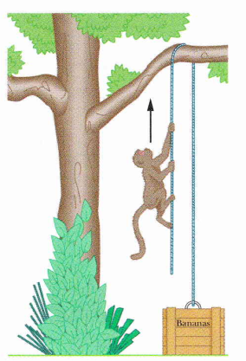
Figure 1

Problem 3
A 10 kg monkey climbs up a massless rope that runs over a frictionless tree limb and back down to a 15 kg package on the ground (Fig. 2) (a) What is the magnitude of the least acceleration the monkey must have if it is to lift the package off the ground? If, after the package has been lifted, the monkey stops its climb and holds onto the rope, what are the (b) magnitude and (c) direction of the monkey's acceleration and (d) the tension in the rope.

Figure 2
Problem 4 (Extra). ChatGPT Answer to Problem 3. What did ChatGPT do wrong?

