Name ________________________
PHY2048C, Practice Quiz 6

A- Read all the quiz once, or twice, before beginning to write. Make sure to comprehend all questions and start with those you feel most confident in.
B – Be clear and concise. There are no extra points for being verbose or writing extra.
C –Only use the white pages that I will provide. You have 50 minutes to answer the quiz.
---------------------------------------------------------------------------------------------------------------------------
Problem 1 (Sears and Zemansky)

In the circuit shown in the figure, when switch S is suddenly closed, the wire L is pulled toward the lower wire carrying current I. Which (a or b) is the positive terminal of the battery? How do you know?
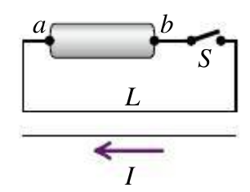

Problem 2 (Sears and Zemansky)

A wide, long, insulating belt has a uniform positive charge per unit area on its upper surface. Rollers at each end move the belt to the right at a constant speed v. Calculate the magnitude and direction of the magnetic field produced by the moving belt at a point just above its surface. (Hint: At points near the surface and far from its edges or ends, the moving belt can be considered to be an infinite current sheet)

Problem 3 (Sears and Zemansky)
The Figure shows, in cross section, several conductors that carry currents through theplane of thefigure. The currentshave the magnitudes I1 = 4.0 A,I2 = 6.0 A, and I3 = 2.0 A, andthe directions shown. Four paths,labeled a through d, are shown.What is the line integral for each path?

