Name ________________________
PHY2049C, Practice Quiz 7

A- Read all the quiz once, or twice, before beginning to write. Make sure to comprehend all questions and start with those you feel most confident in.
B – Be clear and concise. There are no extra points for being verbose or writing extra.
C –Only use the white pages that I will provide. You have 60 minutes to answer the quiz.
---------------------------------------------------------------------------------------------------------------------------
Problem 1
The square loop shown in the Figure on the left moves into a 0.80 T magnetic field at a constant speed of 10 m/s. The loop has a resistance of 0.10 Ω, and it enters the field at t = 0 s. Find the induced emf as a function of time
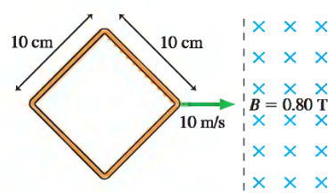
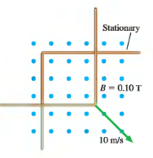

Problem 2
The L-shaped conductor in the figure on the top and right moves at 10 m/s across a stationary L-shaped conductor in a 0.10 T magnetic field. The two vertices overlap, so that the enclosed area is zero, at t = 0 s. What is the induced emf?

Problem 3

What is the magnetic flux through the loop shown in the figure?
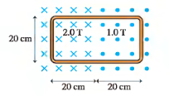

Problem 4
The Figure shows a 10 cm square bent at a 90° angle. A uniform 0.050 T magnetic field points downward at a 45° angle. What is the magnetic flux through the loop?

